**Using WinDiskImager**

1. WinDiskImager is a tool for installing operating system images onto an SD card.
2. The SD card we will be using is a Speed Class 10 card. They cost a couple dollars more but the performance improvement.
3. Place the SD card into the card reader.
4. The folder on your desktop called “Baking a Raspberry Pi” contains two things:
   1. WinDiskImager software
   2. Raspian Operating System Image
5. Plug the SD card reader with the SD card installed. You should open the File Manager to verify the drive letter.
6. Inside the “Baking a Raspbery Pi” folder, open the WInDiskImager folder and double-click on the WinDiskImager application. (Note: you will require Administrative level permissions to do this)

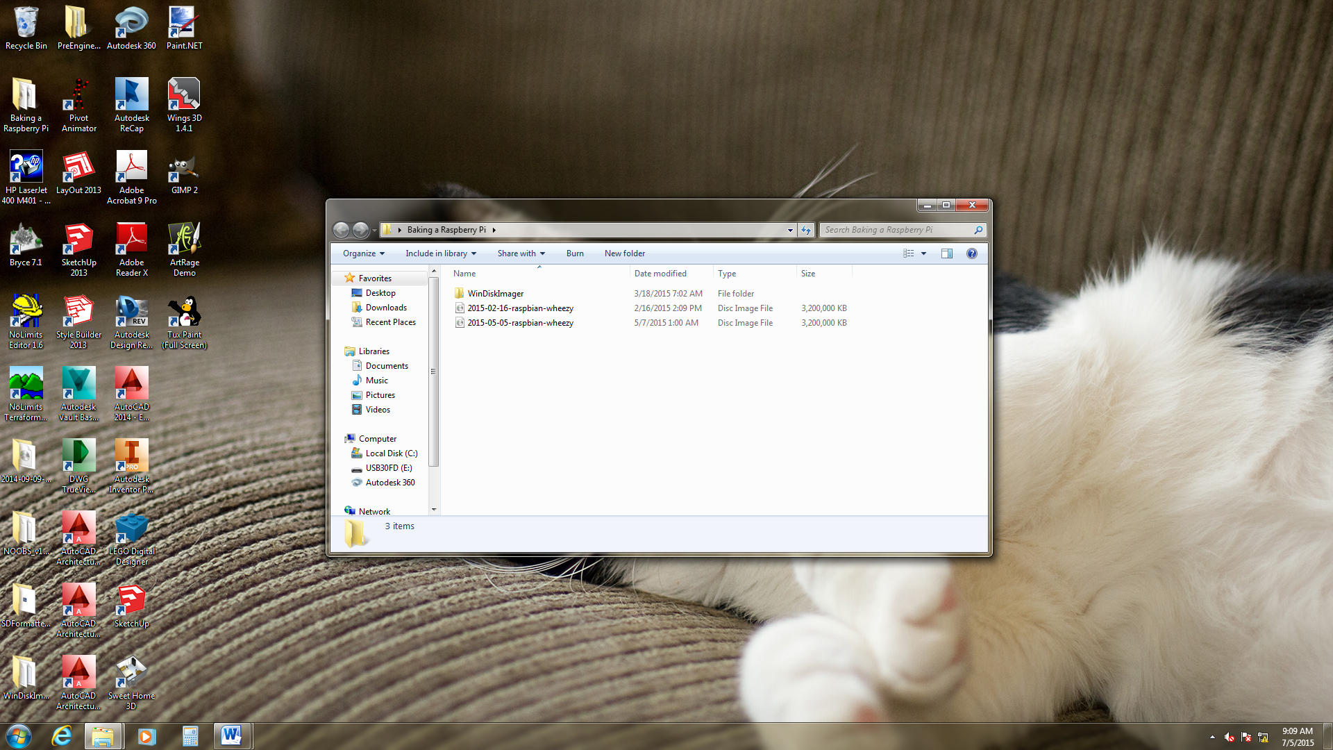

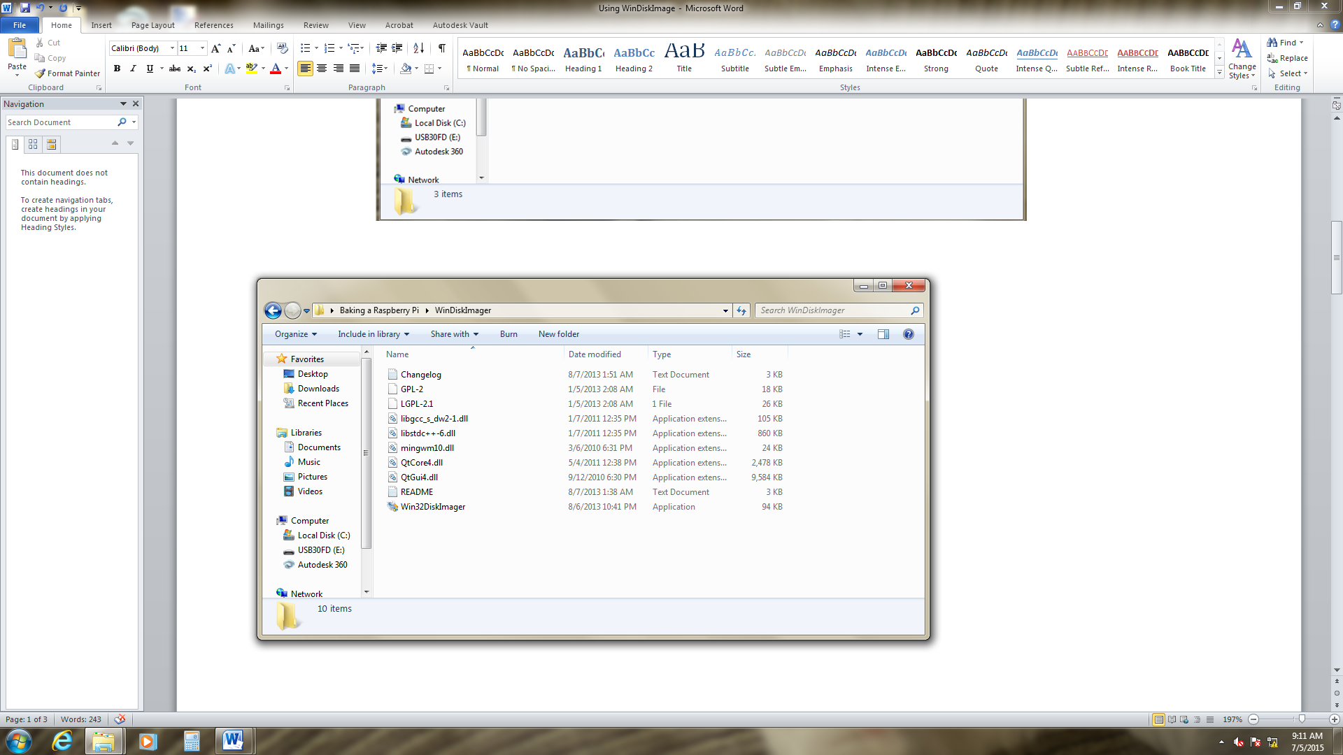

1. You should get this window:

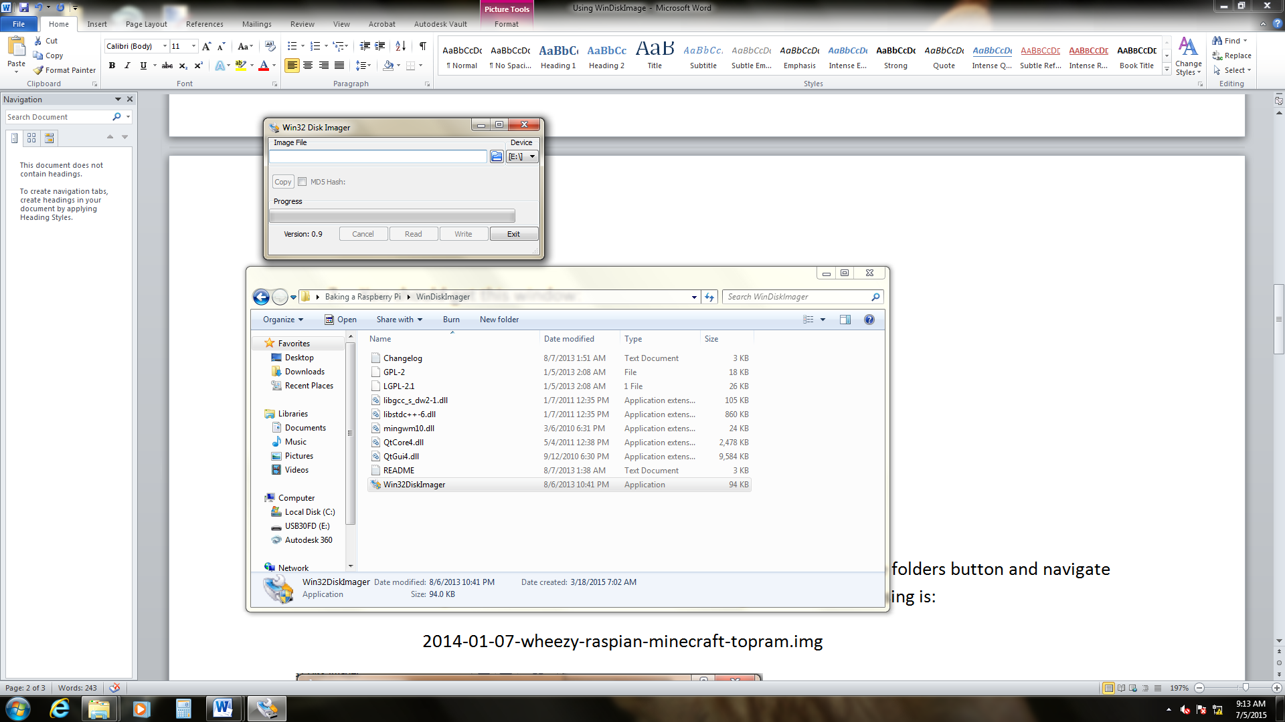

1. Make sure your device is set to the SD card and click on the browse folders button and navigate to the image file on the blue USB drive. The image file we will be using is:

2015-05-05-wheezy-raspian

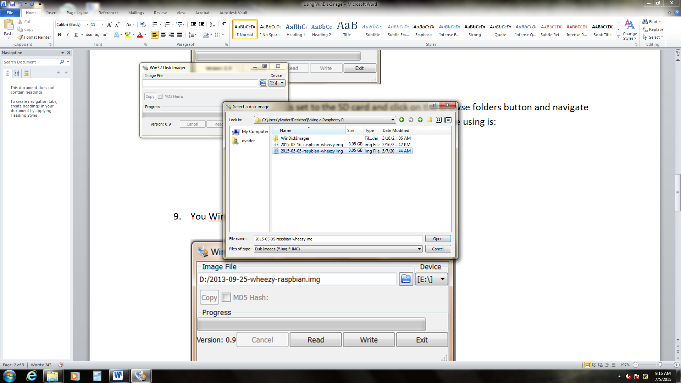

1. You WinDiskImager should look something like this:

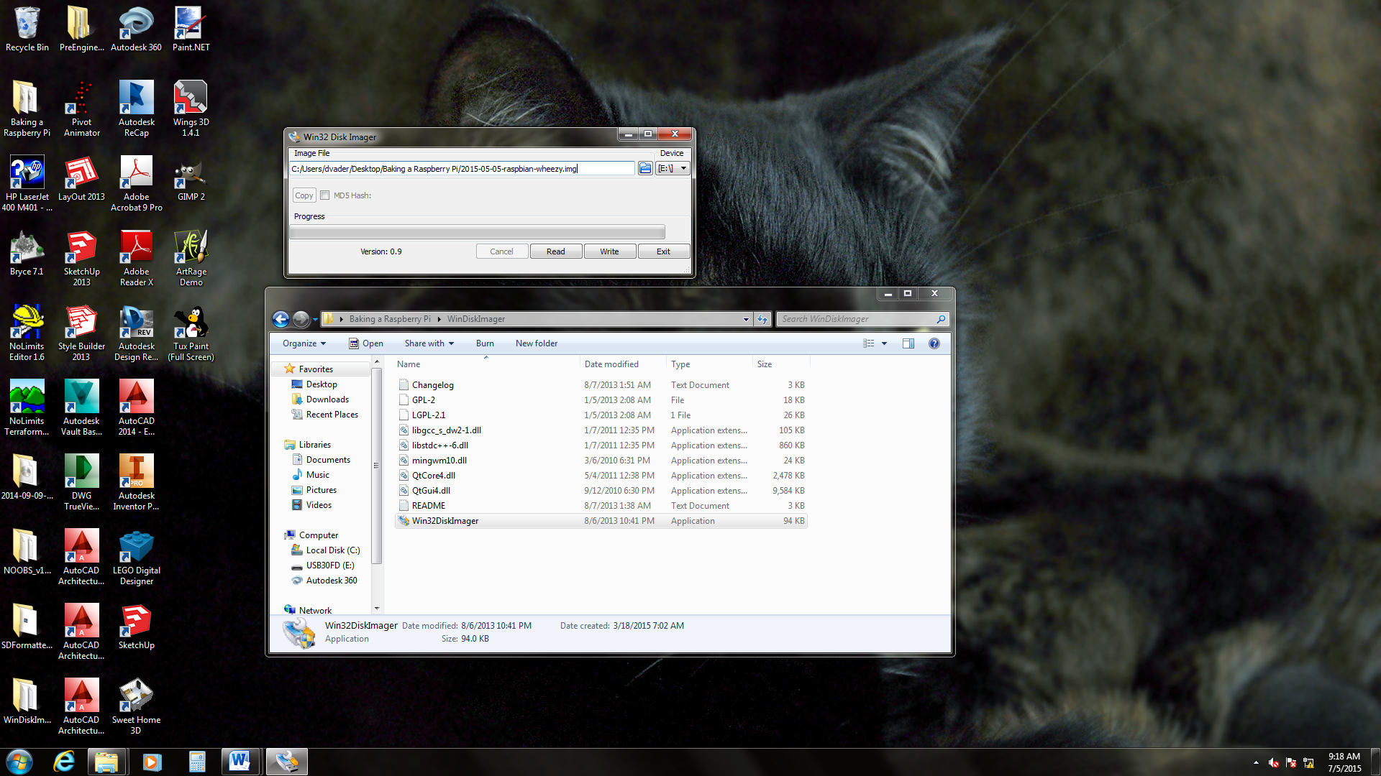

1. Click on the Write button and your image will be written to the SD card.
2. You will first get this warning to make sure you are writing to the correct device.

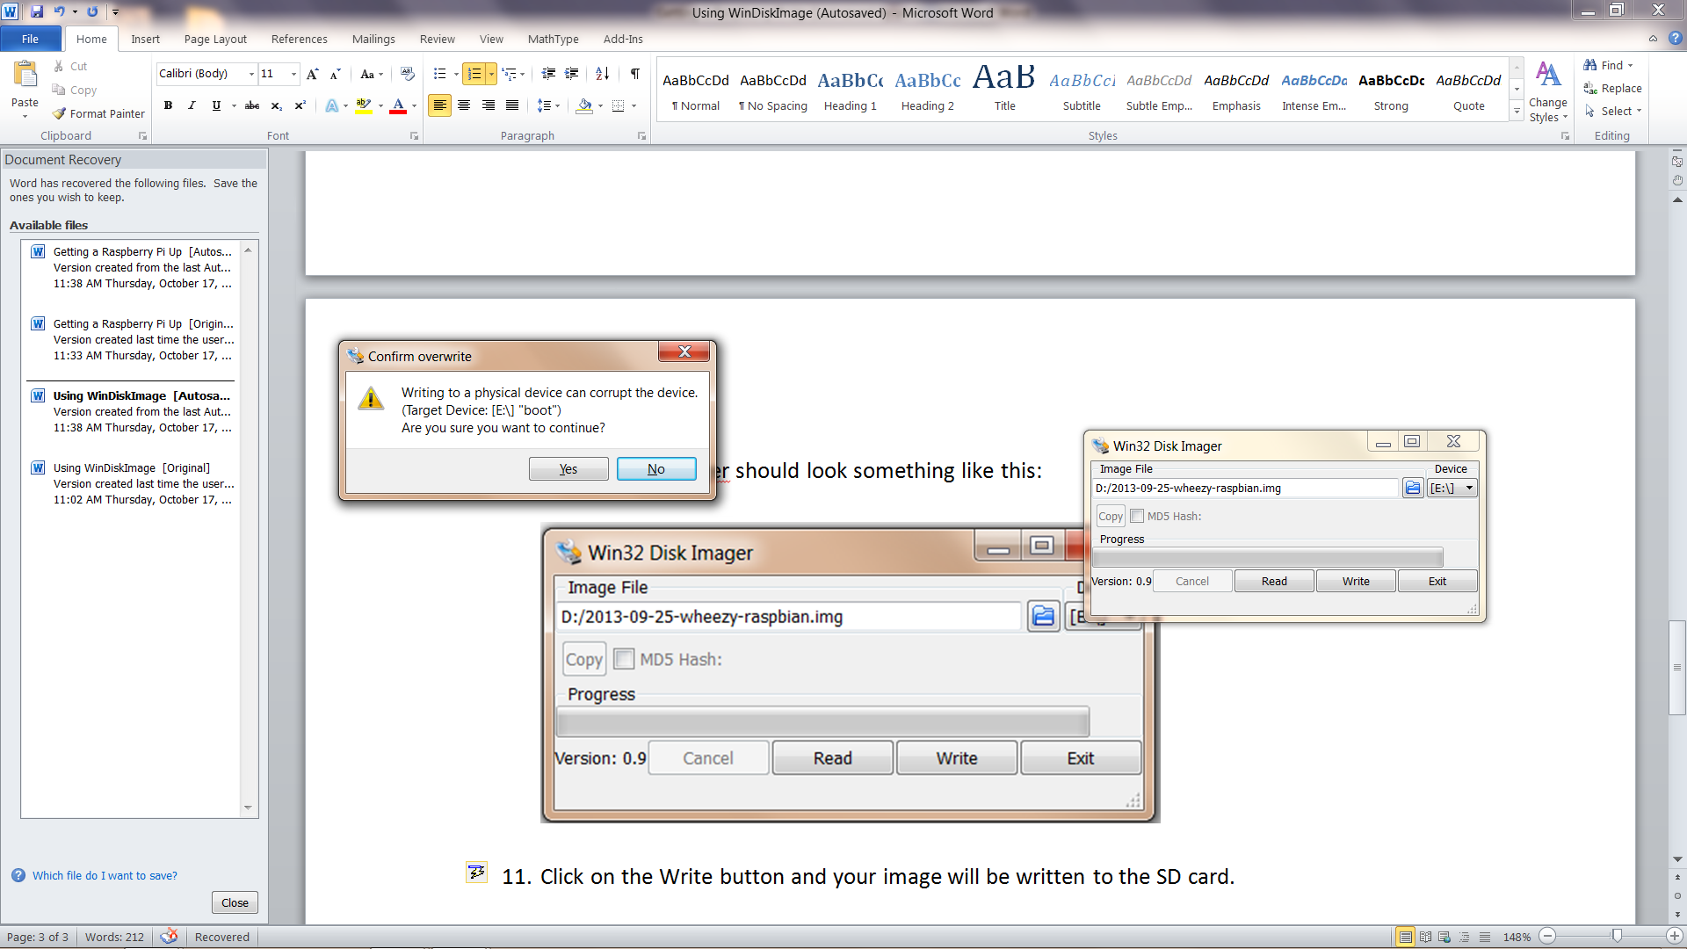

1. Click Yes and the write will proceed.

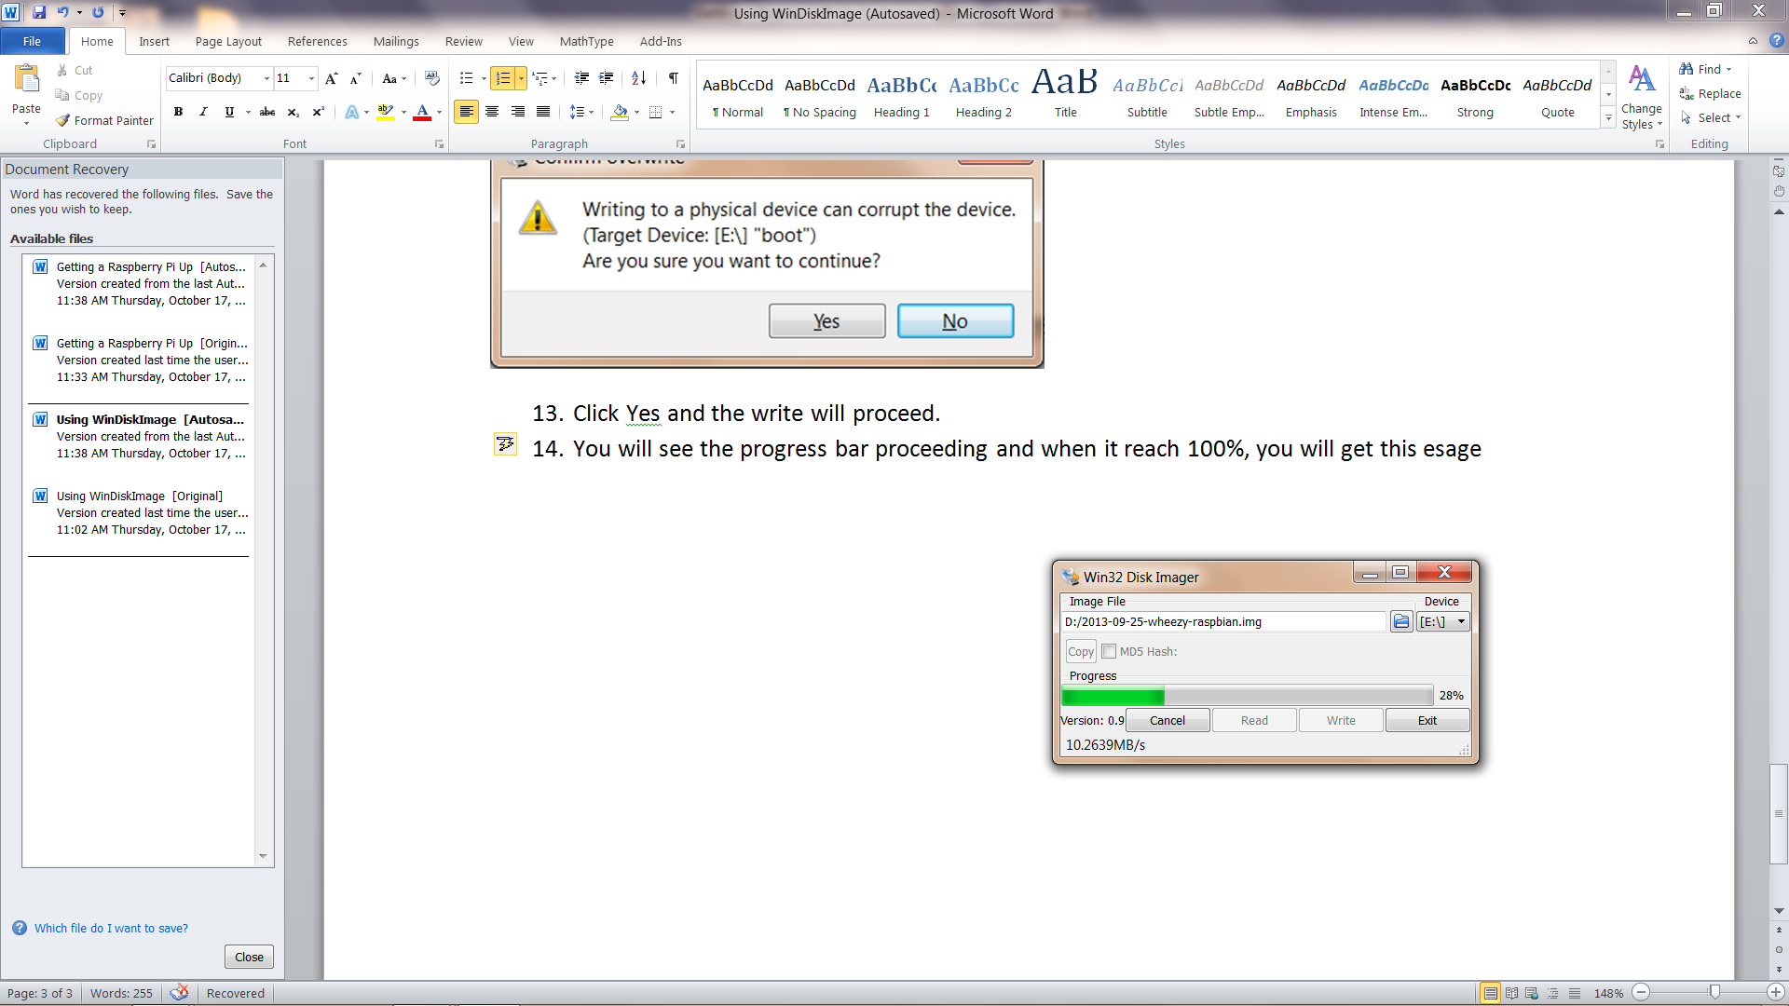

1. You will see the progress bar proceeding and when it reach 100%, you will get this message:

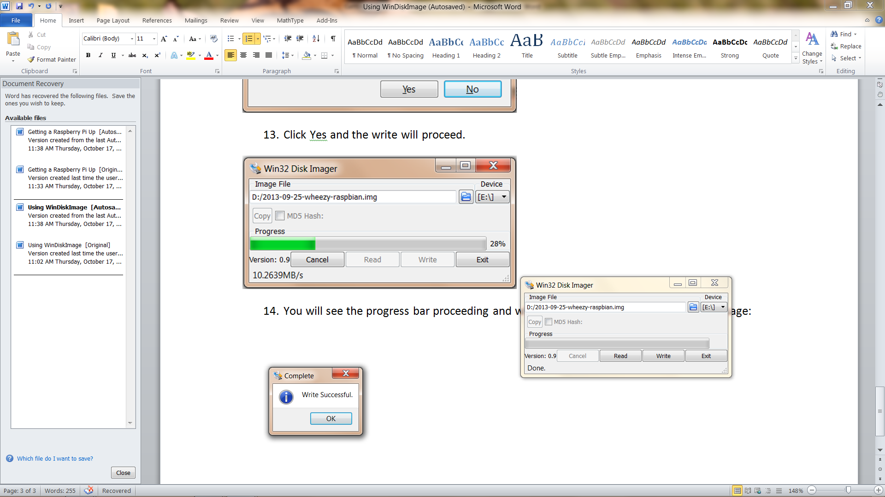

1. Remove the SD card and put it in the Pi…..